|  |
| --- |
| **PGP Encryption and Decryption** |
| **(Training Material) Version: 1.0** |

Table of Contents

**1.** **Steps to learn the configuration of Encryption and Decryption** 2

**2.** **Testing:** 5

**Document Control**

**Revision History:**

|  |  |  |  |  |
| --- | --- | --- | --- | --- |
| **Version** | **Date** | **Author(s)** | **Reviewer** | **Revision Notes** |
| 1.0 |  |  |  |  |
|  |  |  |  |  |
|  |  |  |  |  |

# **Steps to learn the configuration of Encryption and Decryption**

Step 1: Utilize the same package of Exercise 1, but create a new Iflow say PGP_Encryption_Decryption_<userid> and Enter the Description as, “*Iflow for Encrypting a message and decrypting*”

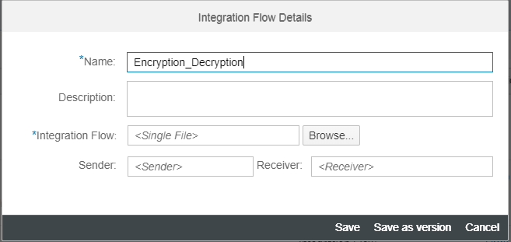

Step 2: Open the IFlow and Change the Sender Participant to “*SOAP_UI*” and delete the target participant

Step 3: Connect the Sender Participant “*SOAP_UI*” to Start and use the SOAP adapter with SOAP 1.1 as protocol. Configure the Connection Tab as per below. Don’t make changes to WS-Security or Conditions tab.

Note: SOAP Address can be anything, but for practice purpose use the naming convention. This will be the endpoint URL for the Interface to trigger. Please replace XXXXX with your user id to keep it unique.

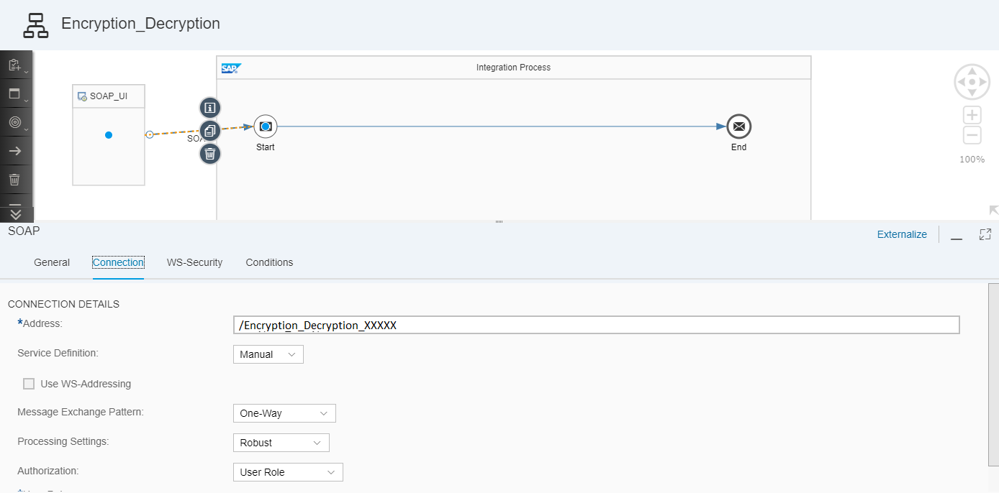

Step 4: In the pallet, choose Transformation -----> Convertor----> XML to JSON Convertor and drop it in-between Start and End Message.

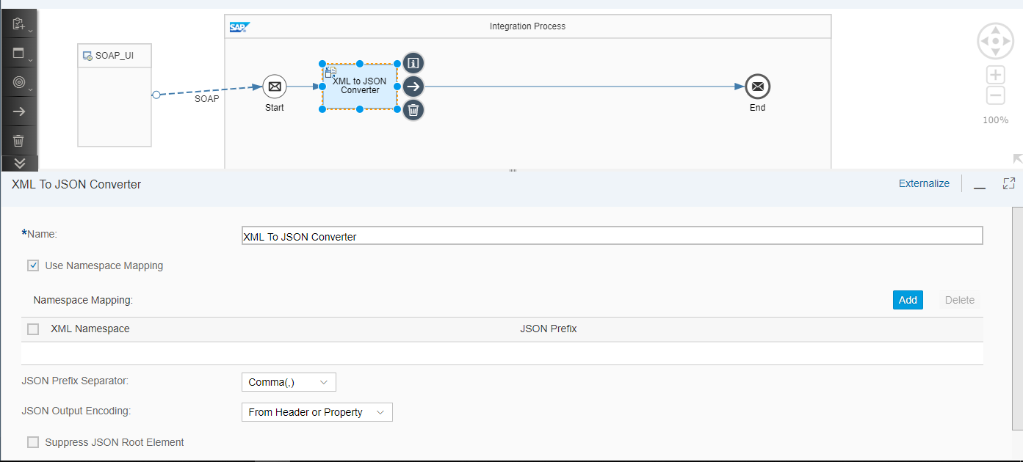

Step 5: In Pallet, Choose Security----> Encryptor----> PGP Encryptor. Place PGP Encryptor between XML to JSON convertor and End message.

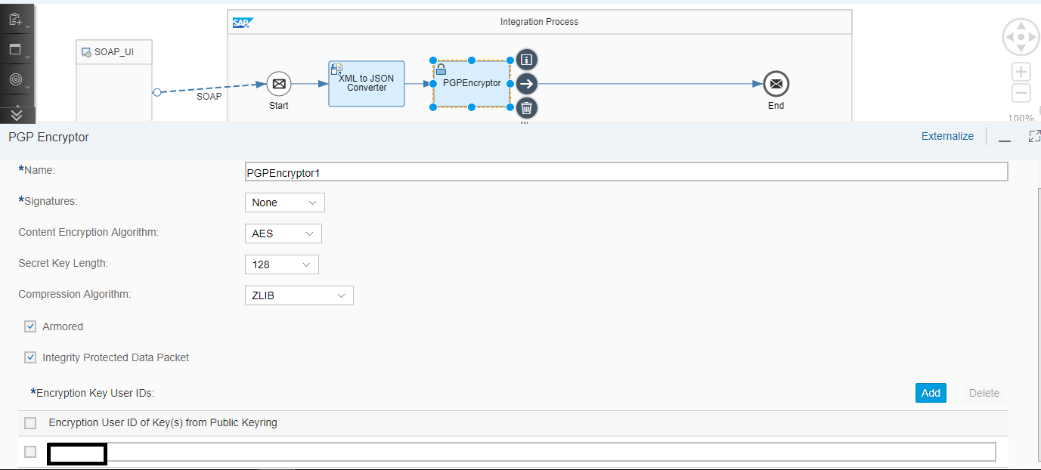

Fill the appropriate Algorithm, Key, and Compression etc and add the encryption Key username used while generating the key.

Step 6: In the pallet, choose Transformation -----> Script---> Groovy Script. Place the groovy script between PGP Encryptor and End message.

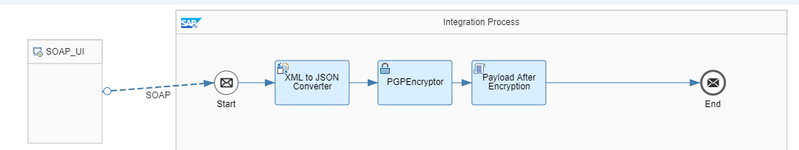

This Script is to store the Encrypted message

Code:

import com.sap.gateway.ip.core.customdev.util.Message;

import java.util.HashMap;

def Message processData(Message message) {

def body = message.getBody(java.lang.String) as String;

def messageLog = messageLogFactory.getMessageLog(message);

messageLog.addAttachmentAsString("Payload1", body, "text/plain");

return message;

}

Step 7: In Pallet, Choose Security----> Decryptor----> PGP Decryptor. Place it between Groovy Script and End Message.

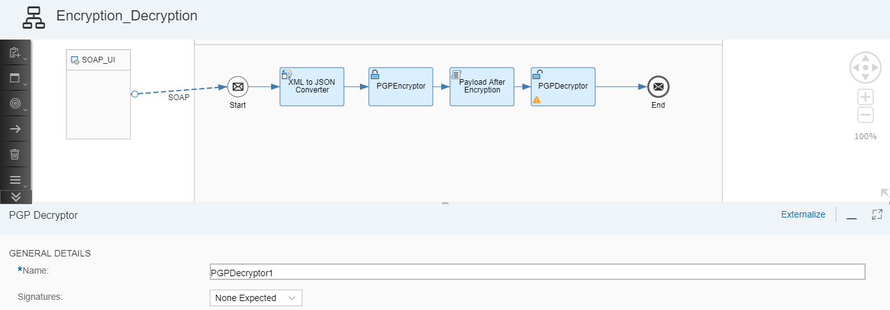

Step 8: Save the Integration Flow

Step 9: Deploy the IFlow

Step 10: Once Deployed, Go to Monitor

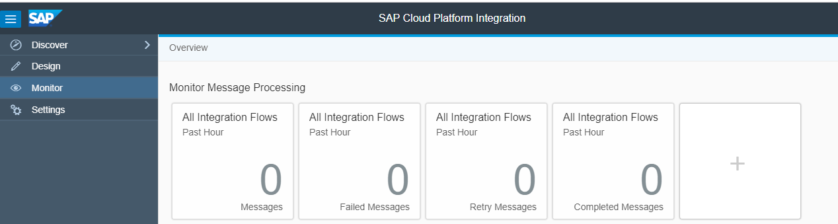

Click on “*All”* tile of Manage Integration Content

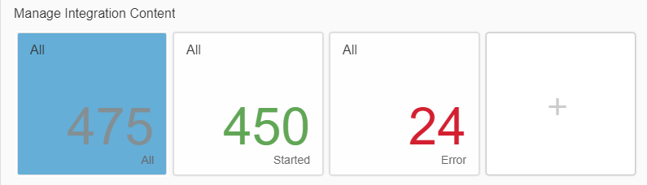

The status of the Integration Flow should be started

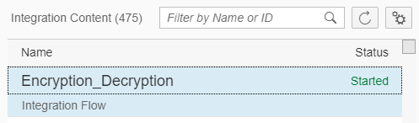

# **Testing:**

Step 11: Now we are good with the Integration flow. The next step is configure the end point in SOAP UI. Copy the end point from Monitor tab. Note. Copy the correct WSDL URL.

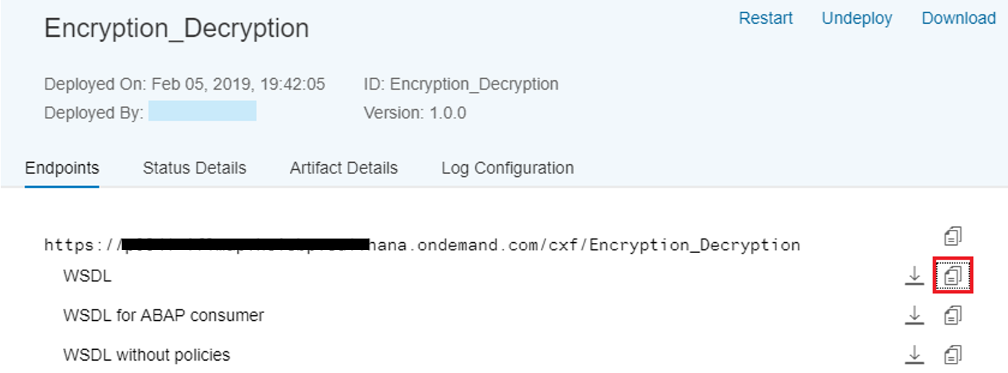

Step 13: Open SOAP UI and create new project and give a suitable name. In the Initial WSDL, paste the URL and click on OK. Once you login, it will ask for Basic Authentication, Enter the S-user ID and Password.

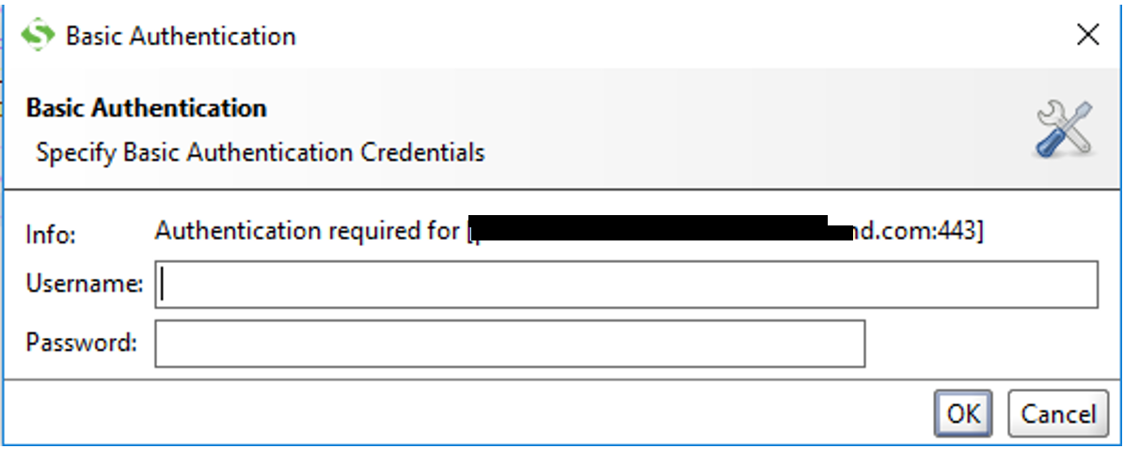

Step 14: The project is created. Now double click on Request 1.

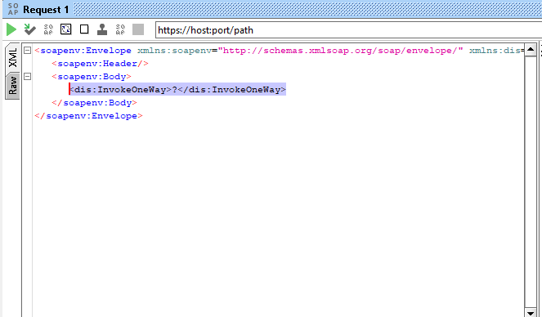

Step 15: Replace the highlighted text in above screenshot with the below payload.

<EmpDetails>

<Empid>1001</Empid>

<Name>John</Name>

<Phone>9856543210</Phone>

<Addr>Bangalore</Addr>

<State>KA</State>

<Client>CPI_CLIENT</Client>

<BU>NA</BU>

<EOM>No</EOM>

</EmpDetails>

Step 16: Goto Manage Integartion Content and open your Iflow. Now copy the end point URL as shown in below screenshot.

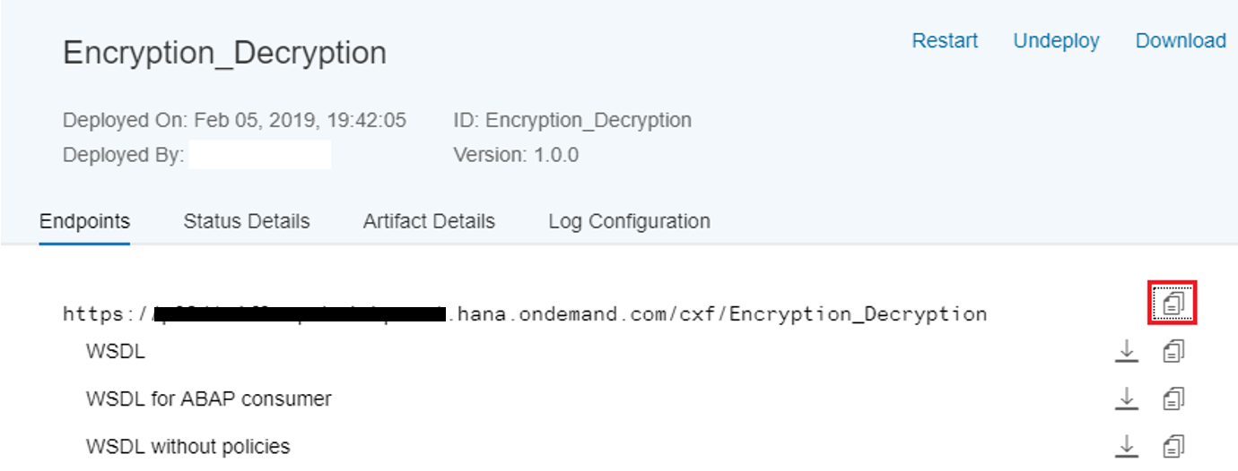

Step 17: Paste in the Address bar of SOAP UI

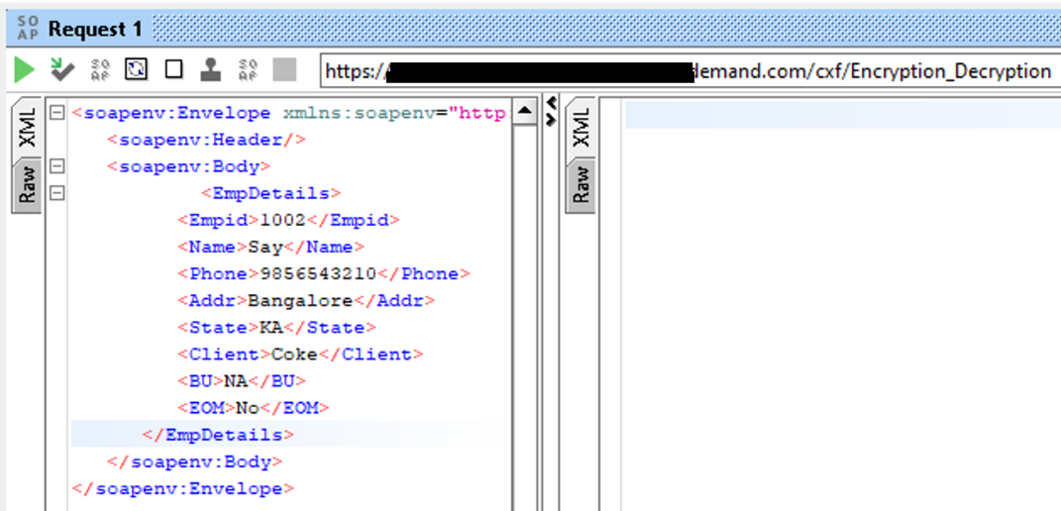

Step 18: Maintain the Access credentials in Properties tab of SOAP UI

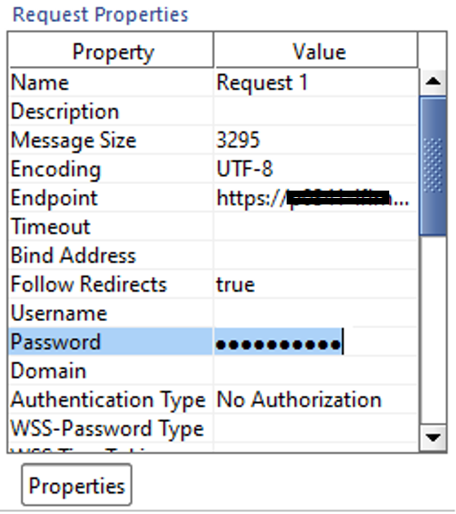

Step 19: Go To the Manage Integration Contents ---> <your iflow>-----> Log Configuration----> Log Level and Change it to Trace

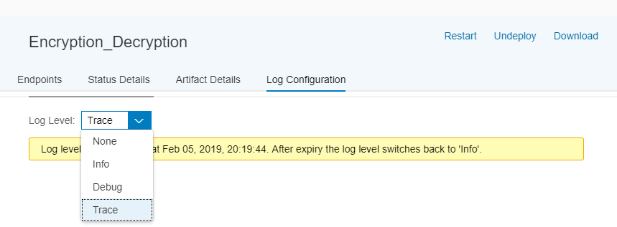

Note: This trace will be enabled only for 10 mins.

Step 20: Now goto SOAP UI and trigger the message

Step 21: Monitor Page and check for Monitor Message Processing

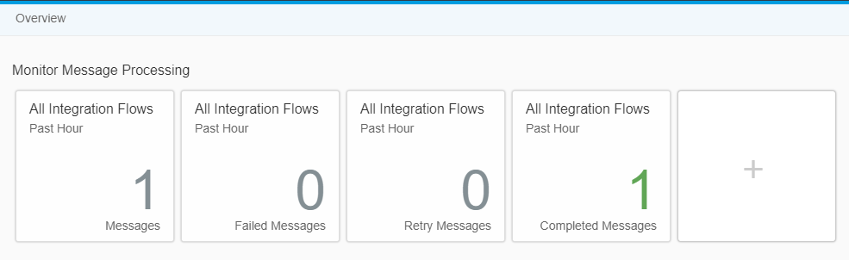

Step 22: Check for Message

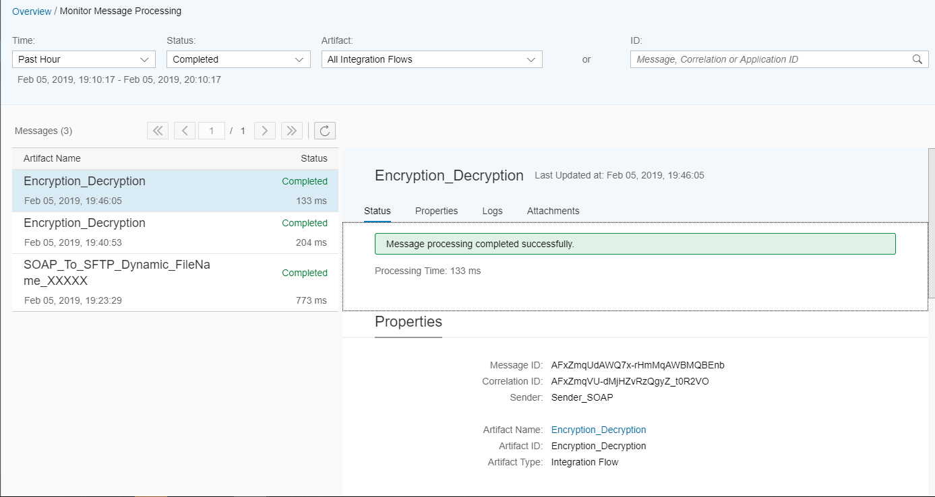

Step 23: Click on Attachments (MPL Attachment)

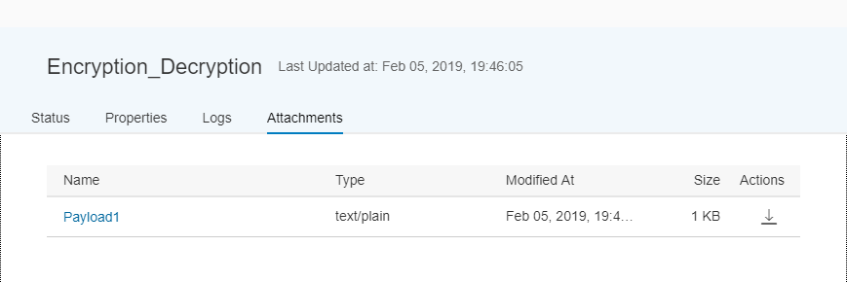

Encrypted Message:

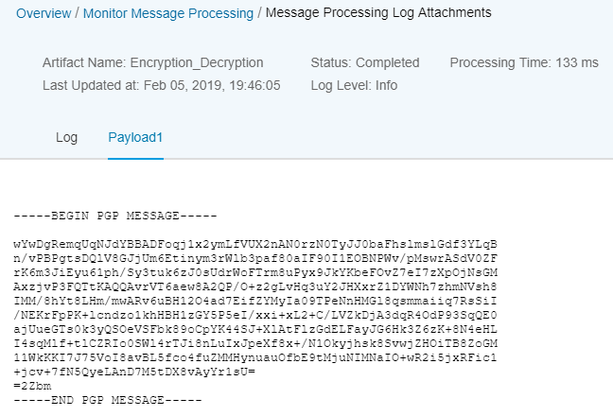

To see the Decrypted Message, Open Trace and Click on End ---> Message Content -----> Payload

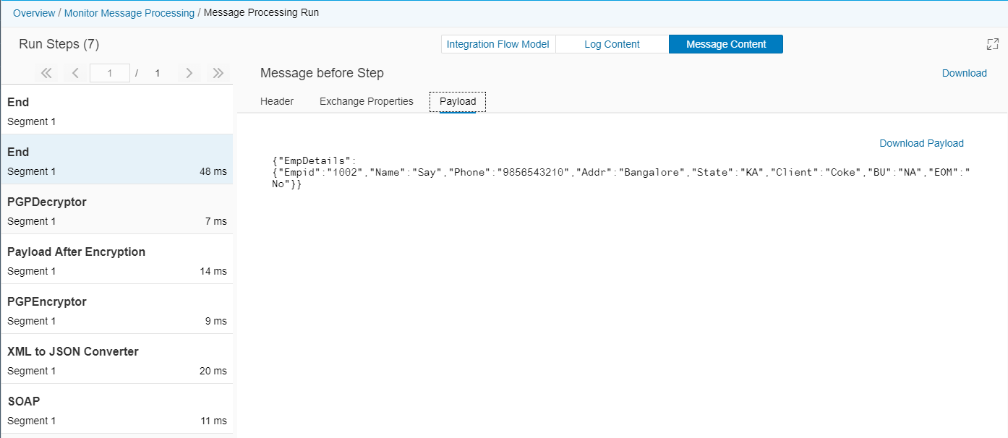

The Important question. Where do we deploy the PGP Keys?

The answer is Manage Security Material ---> Add----> PGP Public Key Ring

Upload the key ring file from desktop. Similarly Manage Security Material ---> Add----> PGP Private Key Ring

